Revision worksheet

Name: ______________________
Grade: I
Subject: Maths
- Count and write.
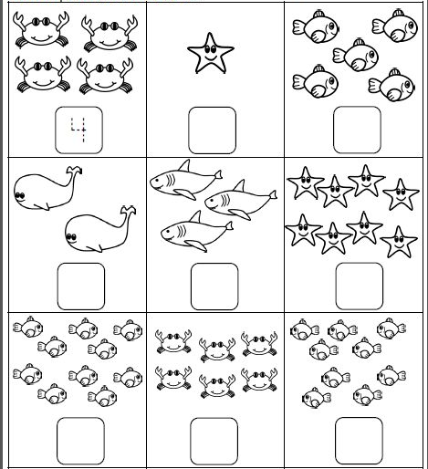

- Fill in the blanks with <, > or =
- 7 __________ 9
- 2 _________ 2
- 6 _________ 8

- Write the missing numbers

1 ______, ______ 4 ________ 6 ______

- Write the number names for the given numbers.
- 6 - ____________

- 10 - ___________

- Arrange the numbers from small to big

5 10 3 8 6

______________________________________________

- Draw the number of objects for the given numbers

- 6

- 3

